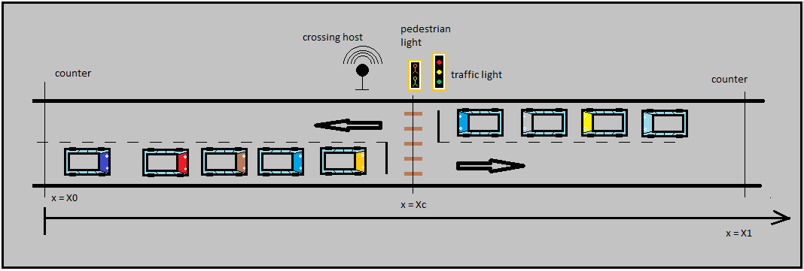
Objects on wifi :
- Scheduler
- Vehicles

Objects on Can :
- Scheduler (Crossing host)
- Traffic light
- Pedestrian light
- Counter
- Pedestrian button

Objects on GPS :
- Scheduler
- Vehicles
- SATELITE

Parameters:
- X0 : control distance

Process Modell Architecture
. . . . .
can bus
couter-1
counter-2
. . .
traffic light
Scheduler Cross-host
wifi
Pedestrian button
GPS
SATELITE

vehicle

vehicle

vehicle

vehicle

pedestrian light

1
2
3
B
1
2
3
C
D
1
2
3
Decision making vehicle
No care vehicle
Next vehicle
pass
stop
LEGENDA
Stop at light
1
2
3
A

Decision making process for a vehicle approaching to a traffic lamp.

